Chapter 10, Problem 18.

Use nodal analysis to obtain V_{o} in the circuit of Fig. 10.67 below.

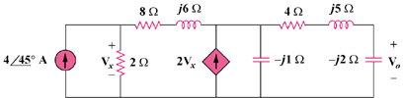

Figure 10.67
For Prob. 10.18.

